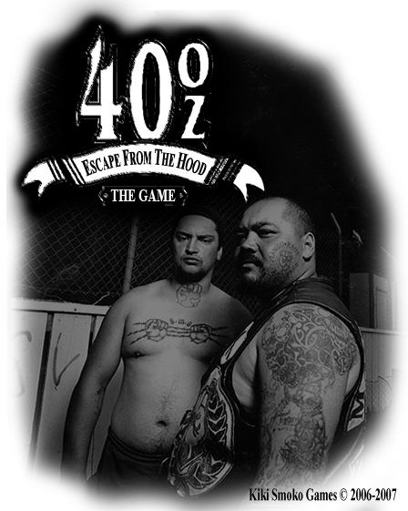

All work Copyright ©1820 by Kiki Smoko Inc.

Written by Sietse Dijks

Version # 1.00

Wednesday, October 23, 2013

Table of Contents

Design History 4

Version 0.10 4

Version 0.20 4

Version 0.30 4

Version 0.40 4

Version 1.00 5

Game Overview 6

Philosophy 6

Common Questions 6

What is the game? 6

Why create this game? 6

What is the purpose of the game? 6

Where does the game take place? 6

What do I control? 6

How many characters do I control? 6

What can the character do? 6

How many levels are there going to be? 6

Do I score points? 6

Are there any obstacles or traps in the game? 7

What is the main focus? 7

What’s different? 7

Feature Set 8

General Features 8

Game Play 8

The Game World 9

The Streets 9

The Physical World 9

Key Locations 9

Travel 9

Scale 9

Objects 9

Day and Night 9

Time 9

Overview 10

2D/3D Rendering 10

Camera 10

Overview 10

Game Engine 10

Overview 10

Game Engine Detail 10

Collision Detection 10

Lighting Models 10

Overview 10

The World Layout 11

Overview 11

World Layout Detail 11

Game Characters 12

Overview 12

Enemies 12

User Interface 15

Overview 15

User Interface Detail #1 15

User Interface Detail #2 15

Weapons 16

Overview 16

Weapons Details 16

Musical Scores and Sound Effects 17

Overview 17

Red Book Audio 17

Sound Design 17

Music Play List 17

Single-Player Game 18

Overview 18

Single Player Game Detail #1 18

Story 18

Hours of Game play 18

Victory Conditions 18

“The First Ideas Appendix” 19

“In or Out Appendix” 19

“Who Did What?” 19

The First Ideas Document 20

General Setup: 20

Plotline: 20

Storyline: 20

Bonus idea: 20

In or Out Appendix 21

In the game 21

Not in the Game 21

Who Did What? 22

Mauk Buursink 22

Sjef van Doorn 22

Paul Dalessi 22

Sietse Dijks 22

# Design History

This is a brief explanation of the history of this document.

## Version 0.10

Version 0.10 is the first version of this design document. It includes the general setup and ideas about our game.

1. I started on this document outlining the game in general.

## Version 0.20

Version 0.20 is the first version of the design where a major revision has been made now that much more is known about the game. After many hours of design, many decisions have been made. Most of these large design decisions are now reflected in this document.

Included in the changes are:

1. Some changes in the design of the level.
2. Changes in some of the characters.
3. Changes in the controls.
4. Added some of the art to this document.
5. Added some more information about the design.
6. Added information for the Rendering system.
7. Added information about the Game Engine.
8. Started with a Foreword.

## Version 0.30

Version 0.30 is a new version of the concept where some small changes are made and some things are added and some more things are known now.

Included in the changes are:

1. Finished the Foreword.
2. Added first ideas appendix.
3. Adjusted some small things.

## Version 0.40

Version 0.40 is again a newer version of the concept. Some things are added or revised.

Included in the changes are:

1. Added some questions in the common questions section.
2. Modified the Foreword.
3. Edited world layout detail.
4. Added information for about the User Interface.
5. Added information about the Weapons.
6. Added information about the Music and Sounds.
7. Added In and Out appendix.
8. Added Who Did What appendix.

## Version 1.00

Version 1.00 is the first complete version.

Included in the changes are:

1. Final checks.
2. Some addition in things that were missing.
3. Final tweaks.
4. Spelling check.

Game Overview

## Philosophy

This game is going to be just for fun. It is meant to be entertaining and to bring back a bit of the old platform feel. Also we wanted to give the player a bit of a look into a so called Hood. We are using an existing engine and we have put some new art in it.

## Common Questions

### What is the game?

The game is going to be a kind of a fast paced 2D platform game. The game is going to look like a mix of Pandemonium and Duke Nukem Manhattan Project. Although the game is in 2D, we will try to give the player the feel that it is a 3D platform game.

### Why create this game?

We are creating this game because we thought it would be a good and challenging assignment for us. Moreover, we all liked the old platform games. Another reason is that there are a lot of games about being a gang member are in 3D like GTA and we wanted to give it another twist.

### What is the purpose of the game?

The purpose of the game is to be entertaining and give a bit of a look inside a Los Angeles neighborhood where violence and gangs rule the streets.

### Where does the game take place?

As described earlier, the game takes place in a so called American Hood of a big city like Los Angeles. Here gang members roam free and gang wars are fought over turf or revenge. We used the typical buildings as a décor and tried to give the game the feel of being in a real Los Angeles neighborhood.

### What do I control?

The player will control a human character named Tekk who is a gang member on the run.

### How many characters do I control?

The player will only control one character.

### What can the character do?

The character can jump and shoot at the bad guys.

### How many levels are there going to be?

For the moment there is only going to be one level.

### Do I score points?

The player doesn’t score points. The only thing that has to be done is kill all the enemies without getting killed.

### Are there any obstacles or traps in the game?

There are some obstacles along the way in the form of fences over which the player has to jump. There are no traps.

### What is the main focus?

The main focus of the game is to escape the Hood alive after stealing something of a rival gang, while killing the gang members that are after the player before they kill the player.

### What’s different?

The difference with all the other games is that it is a simple but enjoyable platform game. It has pretty straight forward controls and has a short learning curve.

# Feature Set

## General Features

Realistic environment.

Gang members.

Guns and unlimited ammo.

Three difficulty levels.

Smooth 3D graphics.

32-bit color.

Keyboard control.

## Game Play

Easy to control.

Easy to learn.

Runs smoothly even on a slower pc or laptop.

There is a lot of action.

Easy aiming.

# The Game World

## The Streets

In the game, the player runs along streets through a Los Angeles neighborhood. On the background the player will see a lot of houses and other buildings. These are all modeled after examples from a real LA neighborhood. All is scaled like in real life. This to get a bit of a realistic view.

The gang members the player encounters while running around are modeled after stereo type gang members. These will be very recognizable for people who have seen GTA or Saints Row.

## The Physical World

### Key Locations

The key location in the world is the street. It currently consists of two main streets, a back alley and a bit of garden.

### Travel

The player moves a long on foot and has to jump over some obstacles.

### Scale

The scale is about the same as in the real world, so the player is going to be 1.90m tall and the buildings are also scaled like real buildings.

### Objects

There will be some objects in the world like the 40OZ beer that will give you back some health. Also there will be a rabbit cage on which the player will land after jumping over a fence. It will break because of the player landing on it and the rabbits will escape and the player can shoot these for bonus points.

### Day and Night

The game takes place in broad daylight, so far there are no plans to make it an option to let the player choose between day and night.

### Time

The time will be real-time, this is because of the scaling and our intention to make the main character behave as a normal person would.**Rendering System**

### Overview

Give an overview of how your game will be rendered and then go into detail in the following paragraphs.

### 2D/3D Rendering

The engine we use for this game is the A6 Game Studio engine. This is a 3D engine in which games are fairly easy make but quite hard to program at least in the version we used.

## Camera

### Overview

The camera we used is fixed on the player and will show the player from the side. Generally the player will be in the middle of the screen.

## Game Engine

### 

### Overview

The Game Engine we use is a straight forward 3D engine. It works with converted models from Maya. The scripts are written in C-script.

### Game Engine Detail

The game engine will keep track of the player, it let’s the player move along a path, it spawns enemies in front of the player at a pre-fixed position, also it will keep track of the fired bullets and if these hit the enemy or not.

### Collision Detection

With the path finding we didn’t need a lot of collision detection. Naturally the player can’t run in to bullets or into the enemies. The rest is handled by the path finding or by animations.

## Lighting Models

### Overview

The lighting we use is the standard lighting from A6 Gamestudio. We didn’t do anything about that and we haven’t found a lot of information on how it exactly works.

# The World Layout

## Overview

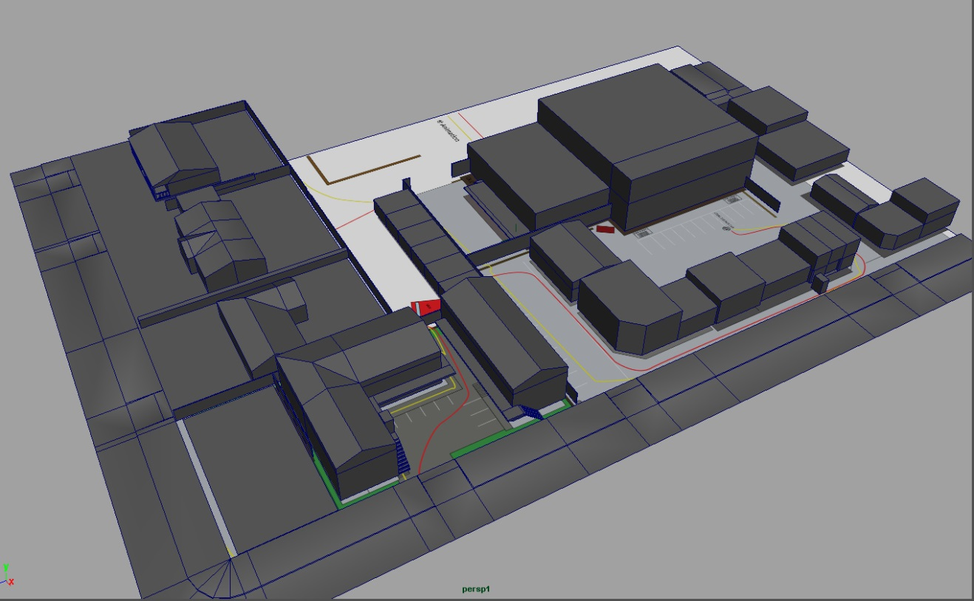

## World Layout Detail

Here is an overview of the level. This is a global version so there are no details, but it gives a good idea of how the game world looks. With this design we tried to make a realistic LA neighborhood. The red line gives an idea of the path the player will take though the level. Starting at the top left corner running down and then following the line at the start positioned at the parking place which is from the centre down.

# Game Characters

## Overview

The characters are all human and for now all the enemy gang members belong to one gang.

## Enemies

The enemies will be members of a rival gang from who the player stole drugs from. It is their role to hunt down the player and prevent him escaping in his car.

**Concept Art**

All made by Mauk.

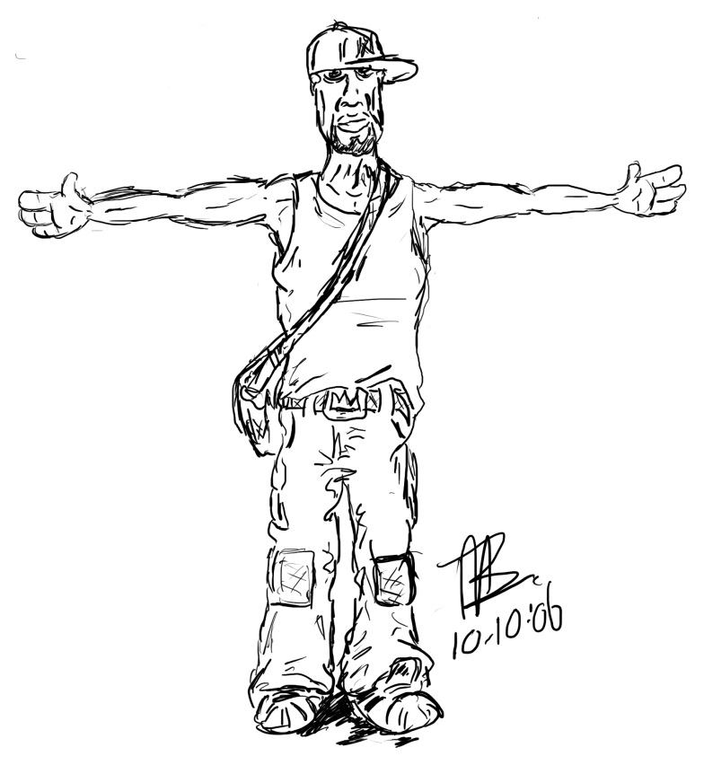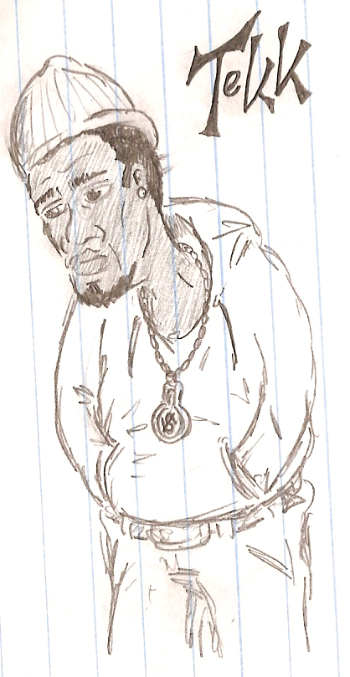

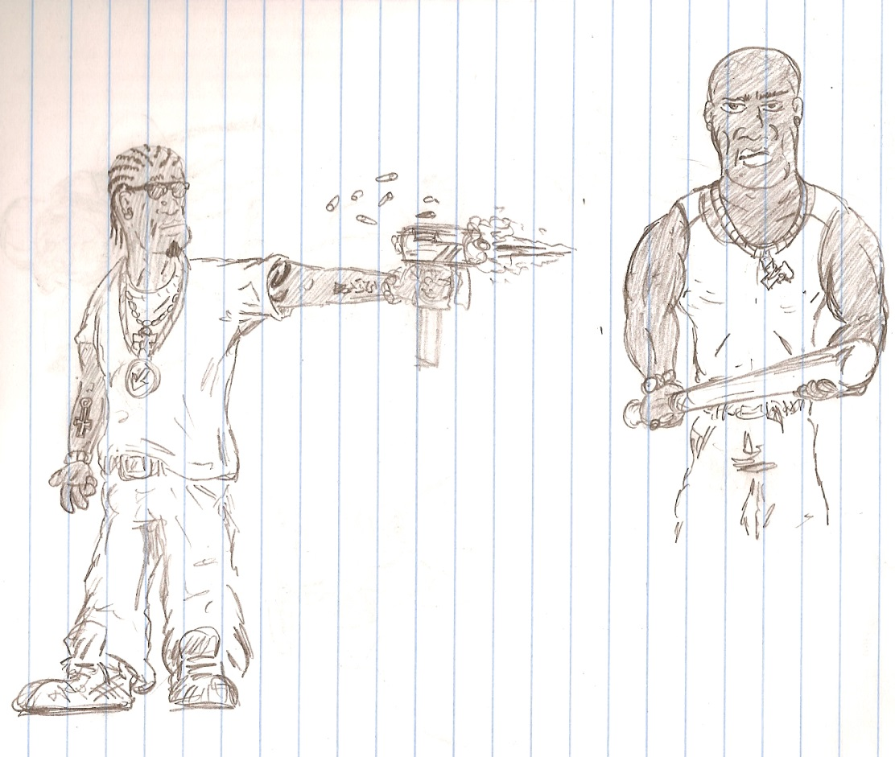

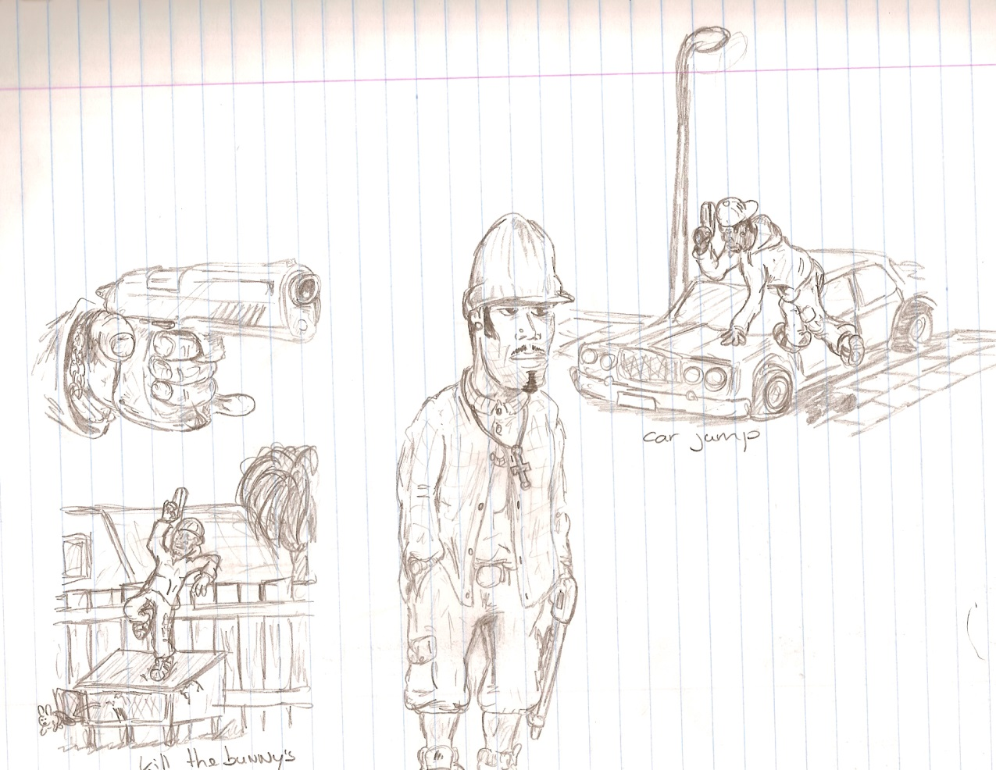

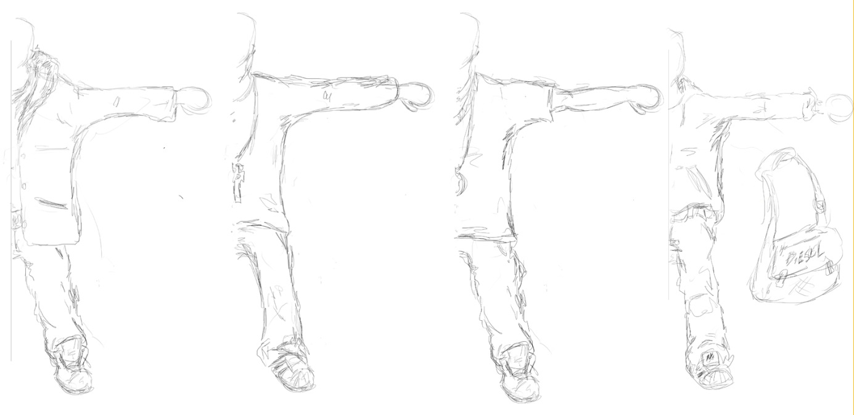

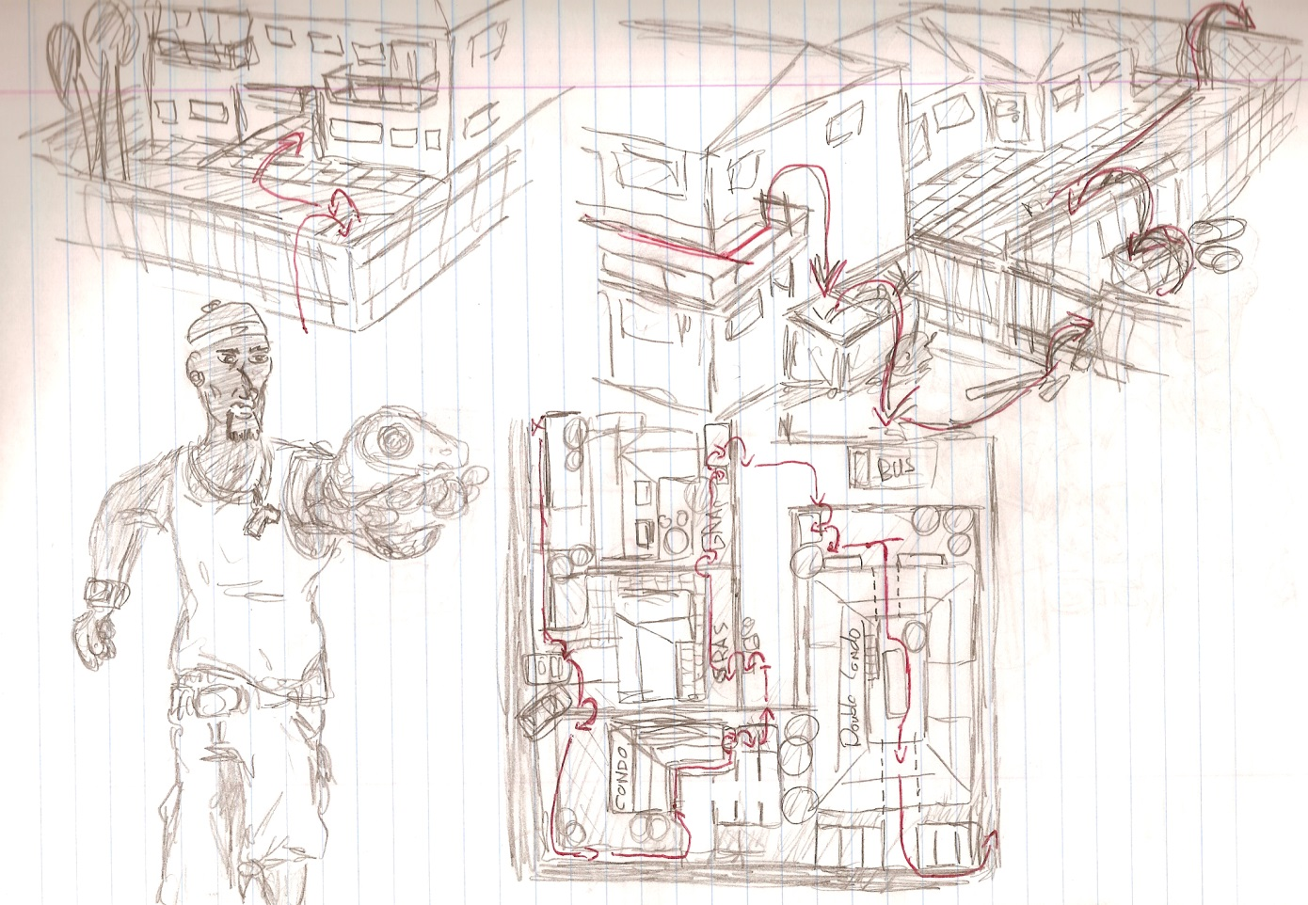

# User Interface

## Overview

We want to have the focus on the game itself and not on details in the screen. Our decision was to give the player a report after he played through the level. This report would consist of the time it took and the number of kills that were made by the player. Since the player has unlimited ammo we won’t display the ammo the player has left.

## User Interface Detail #1

The one thing we did want the have in the game screen is some sort of a health bar showing how many times the player can get hit.

## User Interface Detail #2

We have an introduction screen which has three options for the player. It has a start button, an explanation button and a quit button. The screen is made by Mauk.

# Weapons

## Overview

We wanted to let the player choose from three weapons. Consisting of a machine gun, a handgun or a knife. This would reflect the level of difficulty in the game. The weapons will have a different range but in that range they will do the same damage to an enemy.

## Weapons Details

The handgun will have a range of about one third of the screen. It is modeled in the right hand of the player. The pistol model is based on a real life gun namely a Glock.

# Musical Scores and Sound Effects

## Overview

For the game we wanted to use gangster rap as music. The sound effects will be things like steps, firing guns.

## Red Book Audio

We are not going to use Red Book Audio, but we are going to use the A6 game studio to play the sounds.

## Sound Design

For sound design we will use sounds that came with the A6 Gamestudio. These will be the things like the footsteps.

## Music Play List

For the music we will used to following songs:

Snoop Dogg – Gangbangin’ 101 (feat. The Game)

The Blue Carpet Treatment (2006)

2Pac – Untouchable (feat. Bone Thugs-N-Harmony)

Pac’s Life (2006)

The Game – California Vacation (feat. Snoop Dogg & Xzibit)

Doctor’s Advocate (2006)

Fabolous – Keepin’ It Gangsta (remix) (feat. Styles P, Jadakiss & M.O.P.)

Street Dreams (2003)

Dr. Dre – Here We Go Again (feat. The Game)

Look Out For Detox (2005) (Mix tape)

Clinton Sparks – Take Everything (feat. Sheek Louch, Styles P & J-Hood)

Dj Envy – Bad Guys 7 (2006) (Mix tape)

Styles P – Livin’ 2 Die (feat. Nas & the Game)

Walk witt me (2004)

The L.O.X. – Fuck You

We Are the Streets (2000)

# Single-Player Game

## Overview

The single player game sets the player in the streets of LA and right into the action. The player has to shoot his way out. The main objective is getting to the car and drive away killing all the bad guys along the way.

## Single Player Game Detail #1

## Story

The story behind is game is as follows. The player get’s in to the world of Tekk, a gang member with little or no money. To make some money and the gain respect from his fellow members, he plans to steal some drugs of a rival gang. When he does this, he is seen and the rival gang goes to full alert trying to hunt him down for revenge. Here the player comes in and has to help him survive.

## Hours of Game play

The length of the game will be about five to ten minutes.

## Victory Conditions

The player will win the game by getting to his car alive.

# “The First Ideas Appendix”

In this appendix you will find our very first concept for this game. It is just us brainstorming about what we wanted to see happening and us thinking about the story.

# “In or Out Appendix”

In this appendix you will find an overview of the things we got into the game and things that had to be left out due to time or technical constraints.

# “Who Did What?”

This will be an overview of who did what in the game.

# The First Ideas Document

## General Setup:

* Players: one player, being the main character, interaction with NPC doesn’t exist
* Premises: Player faces multiple enemies a puzzle and a special guest bunny. Because the game is in a Ghetto the enemies are cops, other gang members and racists. The guys are after the player for stealing stuff.
* Resources: The means will be guns, armour suits, health packs (40oz) and an axe. The tools will be screwdriver. There will be bonus bunny.
* Objectives: The objective is to find the keys to your car and get out of the ghetto alive.
* Boundaries: Fixed path, gravity.
* Rules: The player can only jump, run, (crouch), shoot. The player can’t destroy everything in the environment or do “unnatural” stuff.
* Conflicts: The obstacles are fences, doors, crates, cars. The enemies are different guys with or without weapons.
* Outcomes: The player will be victorious if he gets out of the ghetto. The game ends when the player finds his way out or when the player gets killed.

## Plotline:

MC wants to get rich quick or die trying.

## Storyline:

The main character is a wannabe gang member. Because the MC needs money he decides to steal drugs from a rival gang. But when he is there the deal goes bad for the gang members he wants to rob and in the confusion he takes the drugs and the money, but got noticed and now he has to get out of the ghetto by stealing a car.

## Bonus idea:

Guy jumps fence and lands on a rabbit cage. Cage breaks and bunnies escape. Kill bunnies for bonus. If one of the bunnies escapes, more enemies will come. Objective in the game: Open up car and get away.

# In or Out Appendix

In this appendix we will describe the things that made it in to the game and things that we had to leave out or skip.

## In the game

* Tekk, our main character with a gun.
* Some enemies.
* Movement.
* Path finding (one way only).
* Animations.
* The level (houses and other objects).
* Movement.
* Intro screen.
* Explanation.

## Not in the Game

* Shooting.
* The health bar.
* Smart enemies.
* Path finding (two way).
* Music.
* Sounds.
* A Skinned Player.
* Mouse aiming.
* More then one weapon, thus no difficulty level.

# Who Did What?

## Mauk Buursink

* Thinking up the story.
* Drawing the concept art.
* Making the level design.
* Modeling the level.
* Modeling the base character.
* Skinning the level.
* Soundtrack.
* Research.

## Sjef van Doorn

* Programming the path finding.
* Programming enemies.
* Programming the camera’s.
* Programming the menu.
* Trying out mouse aiming.
* Research.

## Paul Dalessi

* Making the first version of the level.
* Giving bones to the character
* Animating the character.
* Skinning the character.
* Skinning the level.

## Sietse Dijks

* Communicating between the members.
* Thinking up the story.
* Making all the documents.
* Making the presentation.
* Helping with the path finding.
* Trying out mouse aiming.
* Making sure everybody did their part.
* Research.